POC – EC2 Instance Using Lambda

Table of Contents

Introduction 4

Objective 4

Pre-requisite 4

Procedure 4

Create a AWS Lambda Function 5

Test your newly created functions 10

Create a CloudWatch Event-Schedule to trigger Lambda function 11

References 16

**Revision History**

|  |  |  |  |  |  |
| --- | --- | --- | --- | --- | --- |
| **#** | **Date** | **Version #** | **Section Changed** | **Details of changes made** | **Approved By** |
| 1 | 17/01/2017 | 1.0 | Draft |  |  |
| 2 | 18/01/2017 | 1.1 | Created |  |  |
|  |  |  |  |  |  |

|  |  |  |
| --- | --- | --- |
| **Prepared/Modified by** | **Role** | **Date of Preparation** |
| Paras Mani Jain | System Engineer | 17/01/2017 |
| **Reviewed by** | **Role** | **Date of Review** |
| Sukhbir K Bhavra | Technical Architect | 18/01/2017 |
| **Approved by** | **Role** | **Date of Approval** |
|  |  |  |
| **Version Number** |  |  |

# Introduction

This document describes the process to start and stop EC2 instance at particular time using AWS lambda and CloudWatch

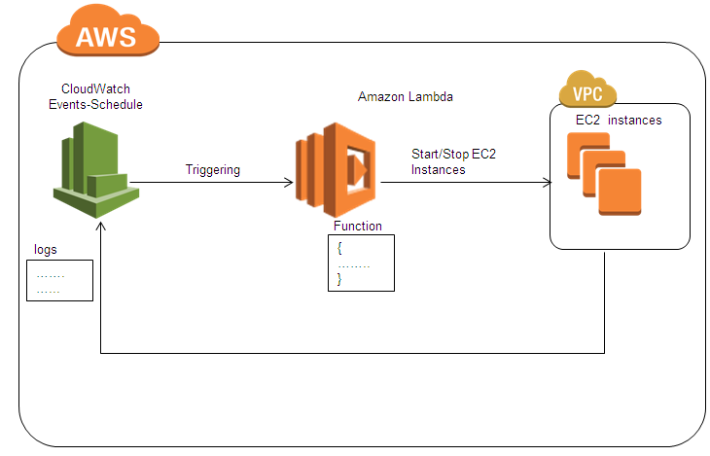

We are creating a CloudWatch Events-Schedule which will trigger the lambda function to start/stop the EC2 instances at desired instant of time

# Objective

Understand the process to start and stop EC2 instance at particular time using AWS lambda and CloudWatch

# Pre-requisite

* AWS account, IAM user access, CloudWatch, AWS Lambda

# Procedure

1. The following instance is in running state, we have to stop this instance using cloudwatch and AWS lambda at particular instant of time

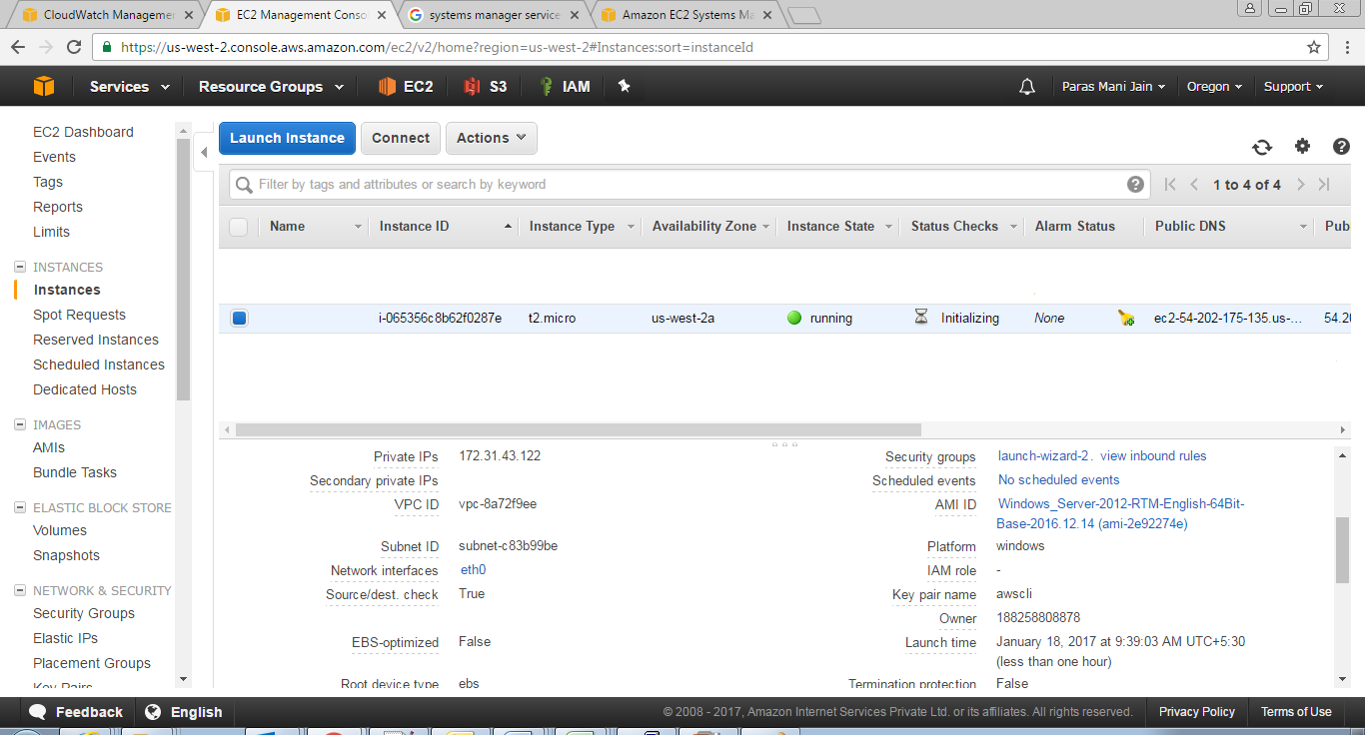

## Create a AWS Lambda Function

1. Open the AWS Management console
2. Click on **Lambda** under **Services**.

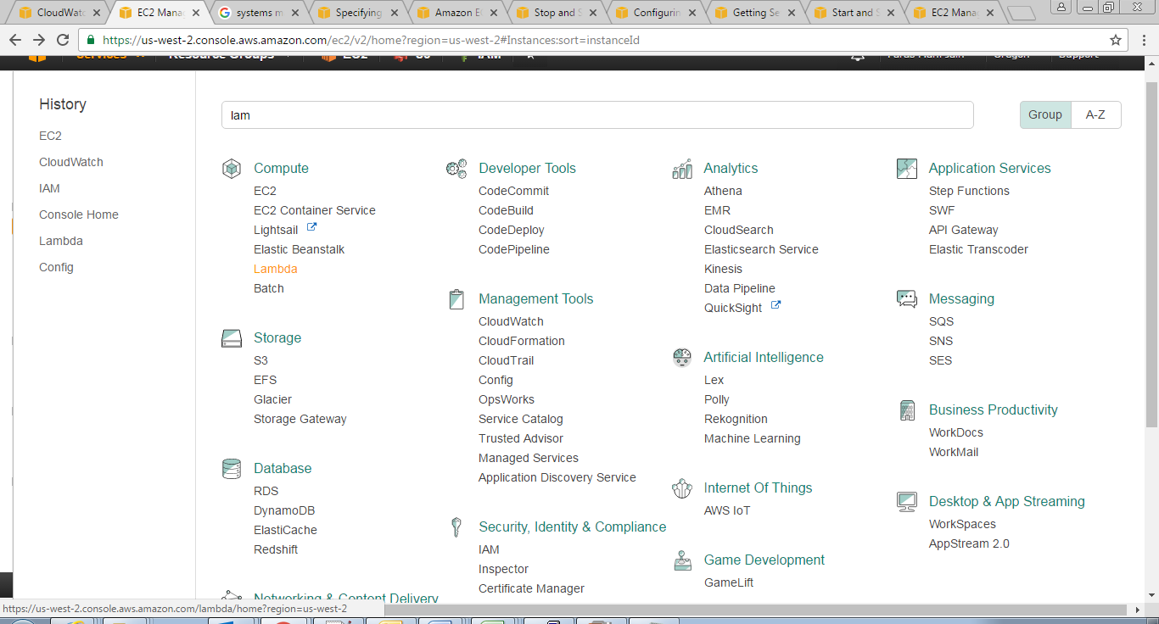

1. From **AWS lambda** console, click on **Get Started Now** button.

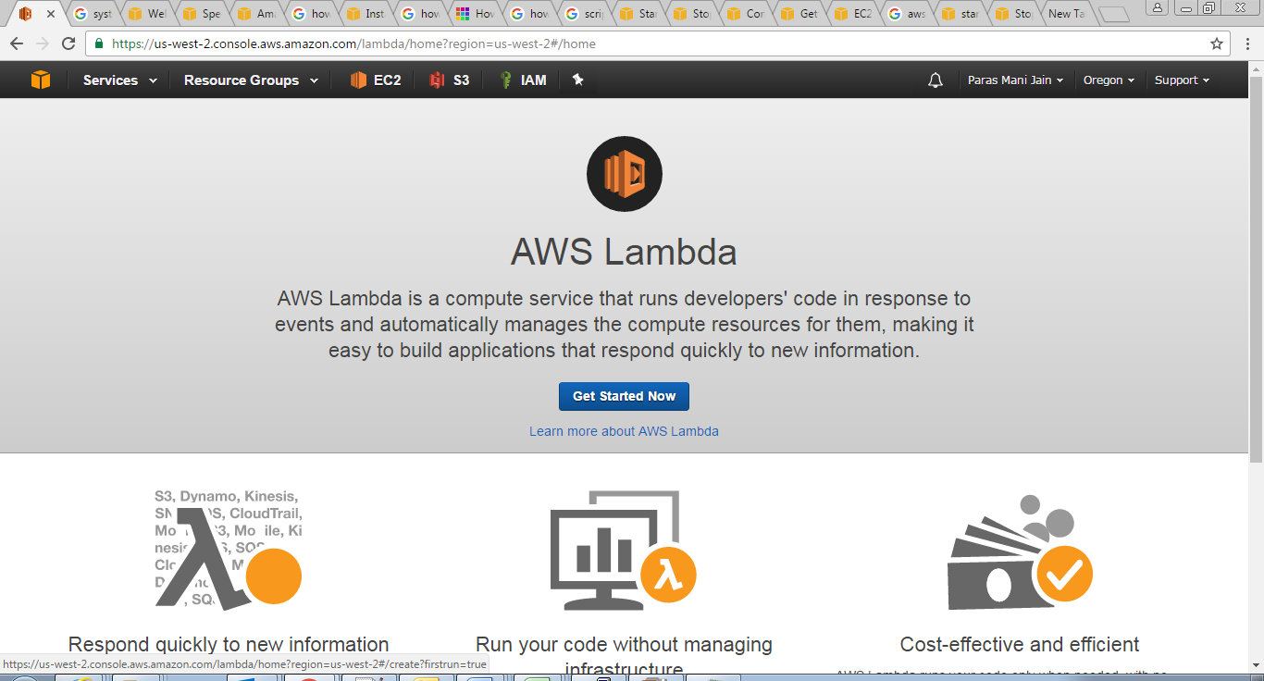

1. Under **Select buleprint** tab, Select on **Blank Funtcion**

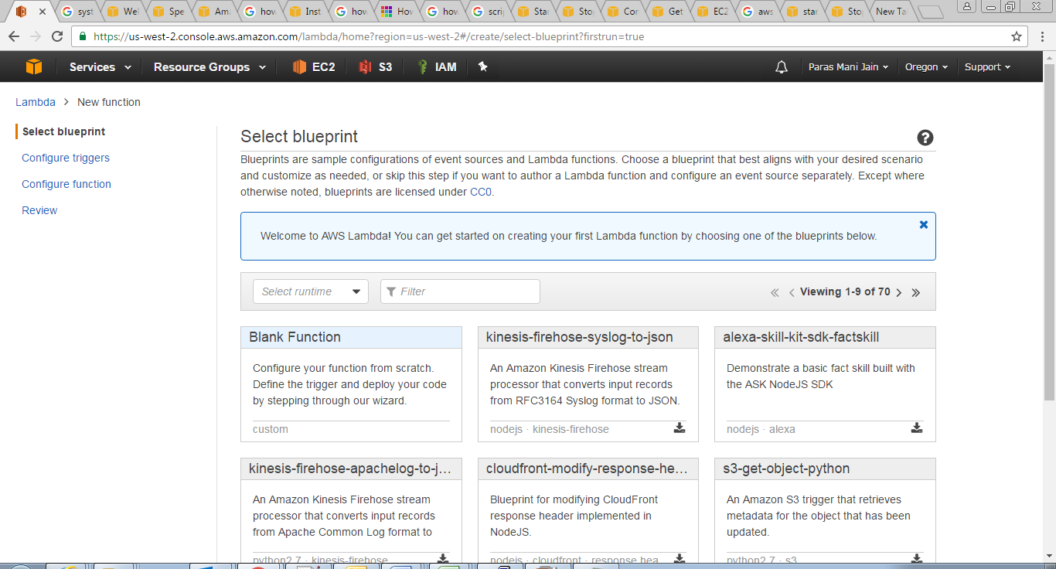

1. Choose **CloudWatch Events –Schedule,** provide the **Rule Name,** **Rule description**, select **cron** in **Schedule expression** and set **enable trigger** on **.** Click on **NEXT** button

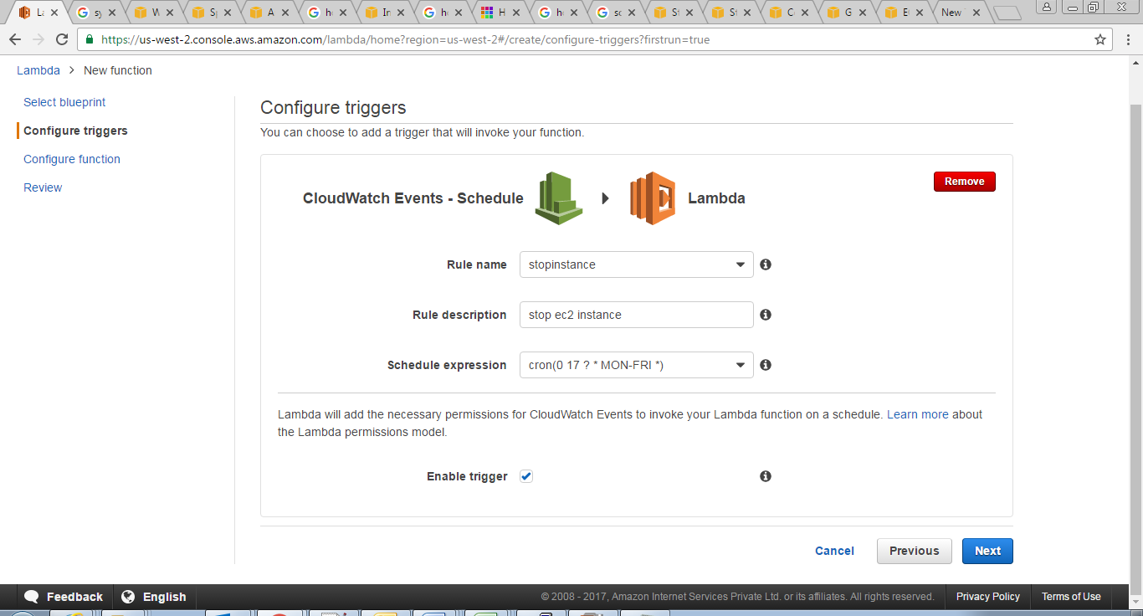

1. You will redirected to the following page,Under the **Configure Function tab,** provide the **Name, Description,** in **Runtime** choose **Python 2.7**

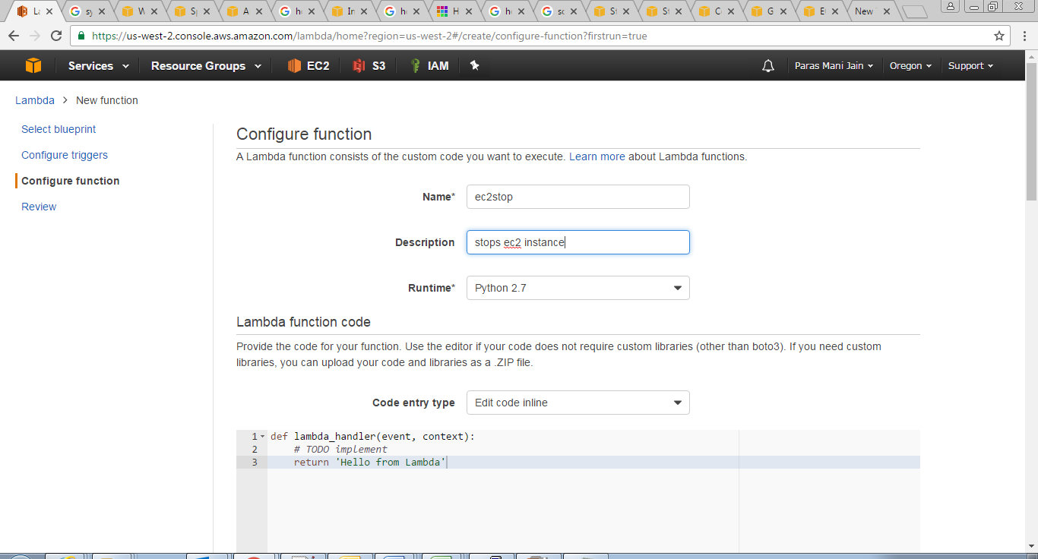

1. Enter the following in the sample code

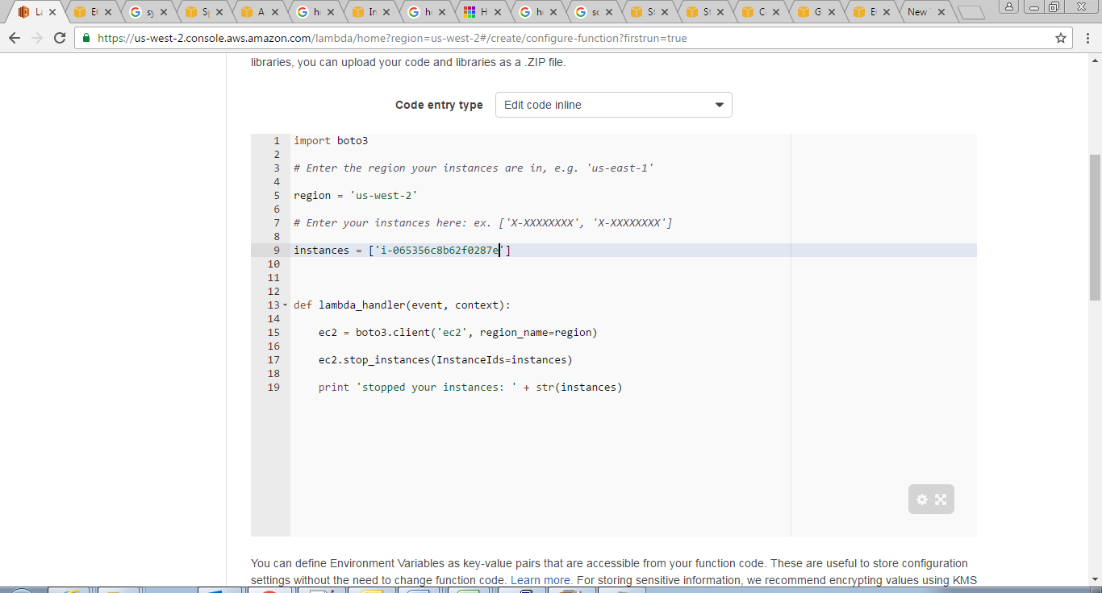

1. Under **Lambda Function Handler and role** tab**,** in **Role** choose **Create a** **custom role** you will be redirected to the following page as shown in step 10

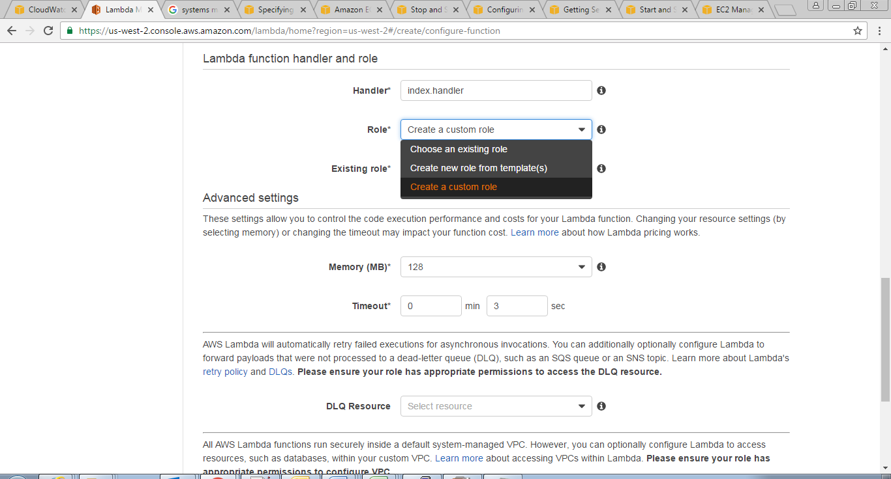

1. Under **Role Summary** tab, in **IAM** role select **create a new IAM Role;** in **Role Name** provide the name. Choose **View Policy Document**, **Edit**, and then edit the policy as follows

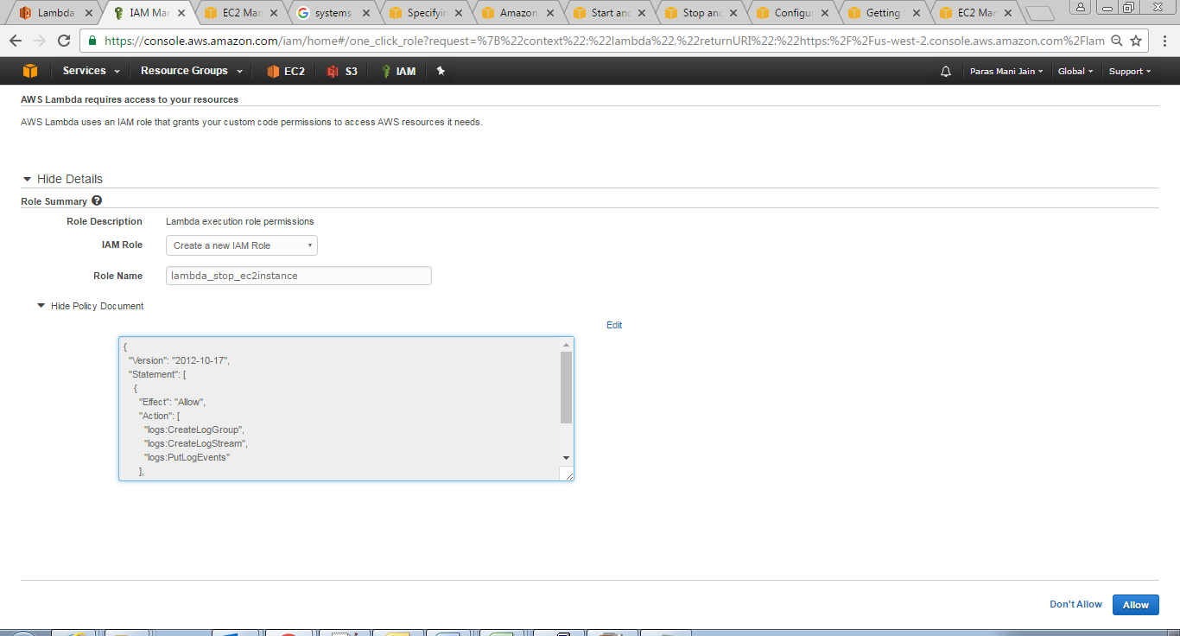

1. Click on **Allow** button. You will redirected to AWS lambda page as shown in step 12
2. In **Advanced settings**, give 0 min 10 seconds in **Timeout**
3. Choose **Next** to review your function configuration, and then click on **Create function** button

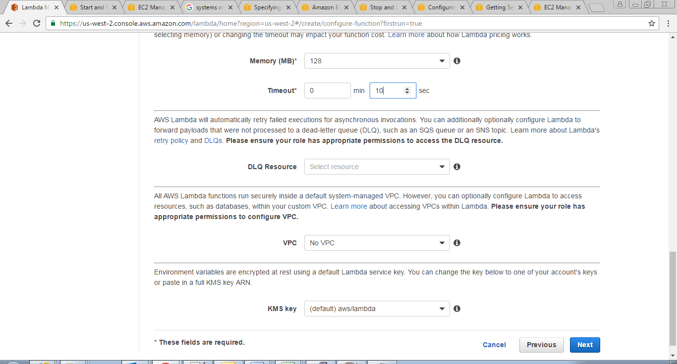

1. Repeat steps 2-8 and 12 to create another function that will start your instances again, using the following code



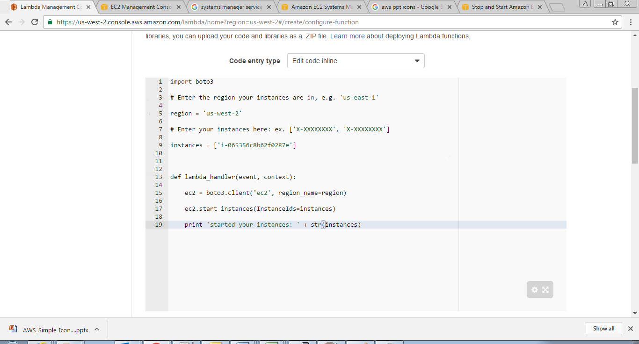

**Note:** You can use the previously created IAMRole (steps 9-11) for the function that will start your instance.

## Test your newly created functions

1. Now you can see the newly created function on **aws lambda dashboard.** Click on **Test**

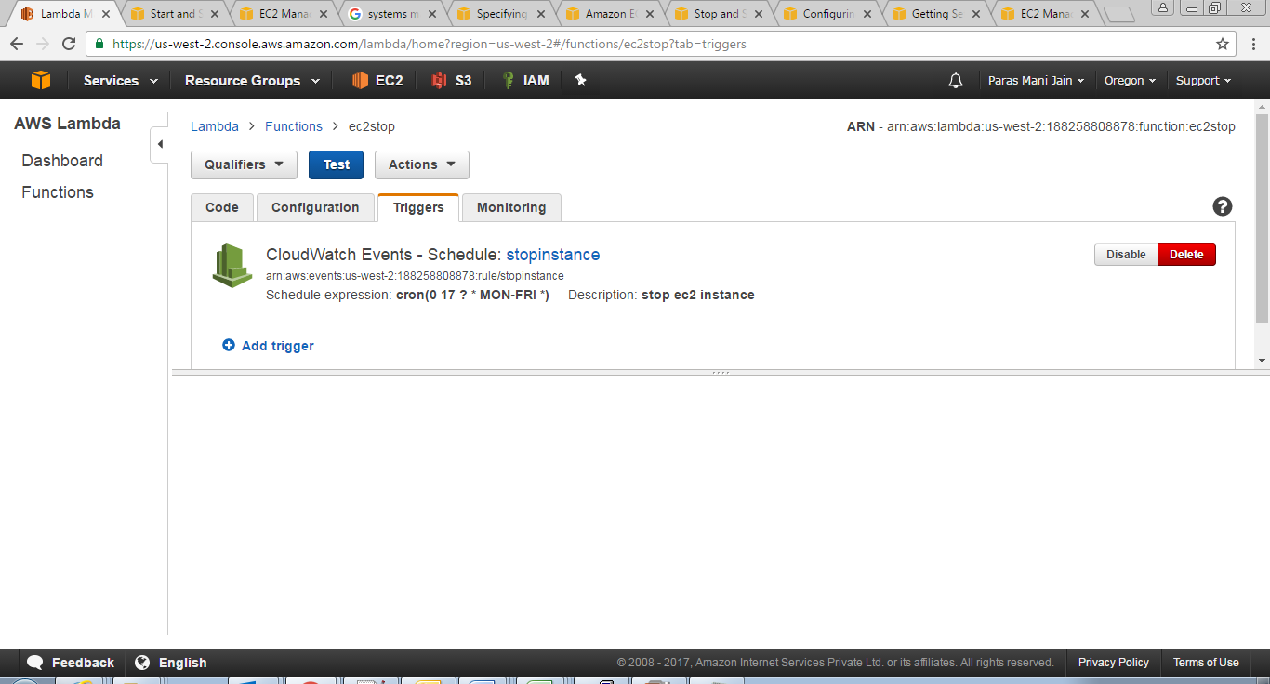

1. A popup window will open as shown below, click on **Save and Test**

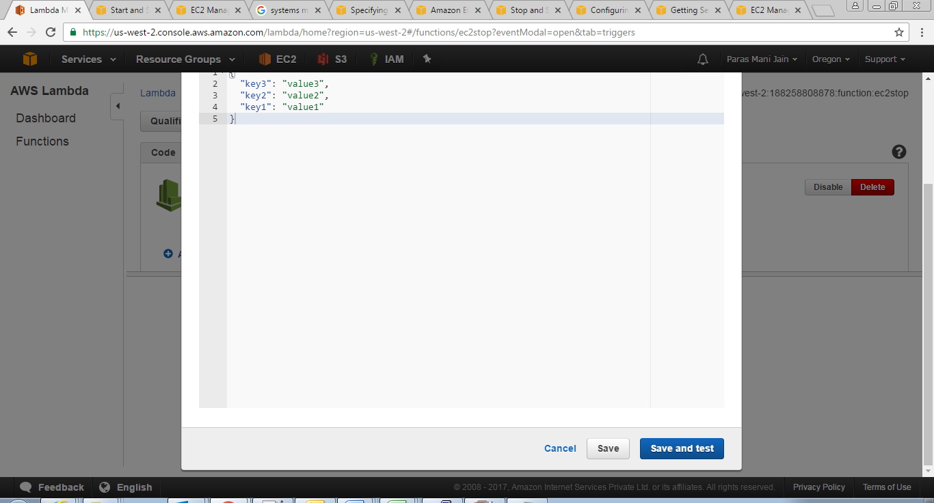

1. You will see the following screen.

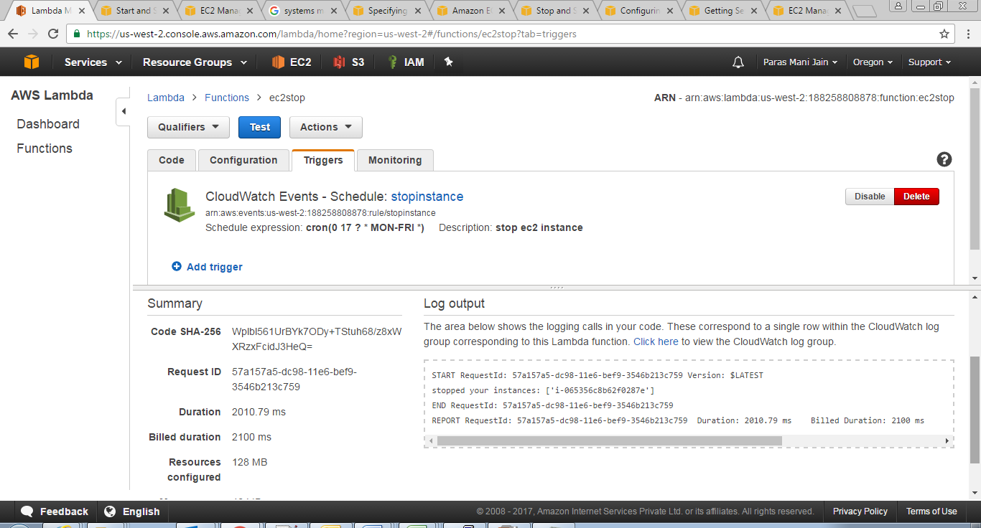

## Create a CloudWatch Event-Schedule to trigger Lambda function

1. Click on **CloudWatch** under **Services,** you will be redirected to the following page as shown in step 19

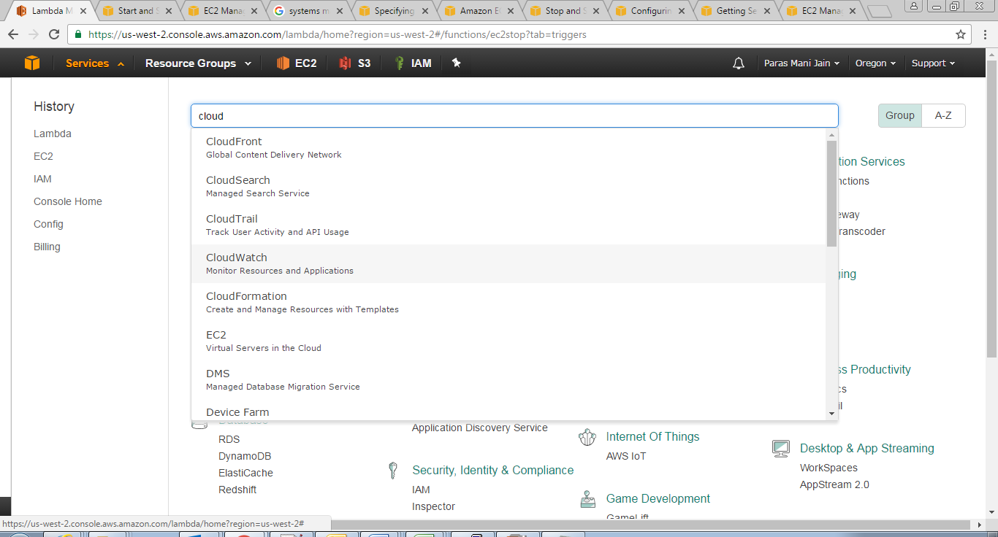

1. Click on **Events** from the Left panel.

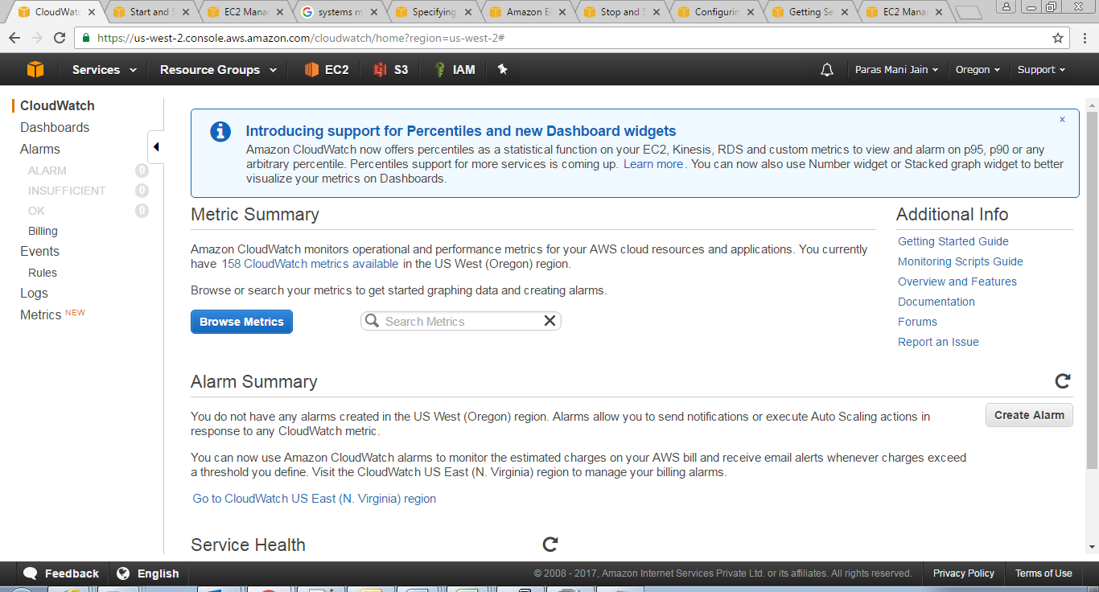

1. Click on **Create rule**

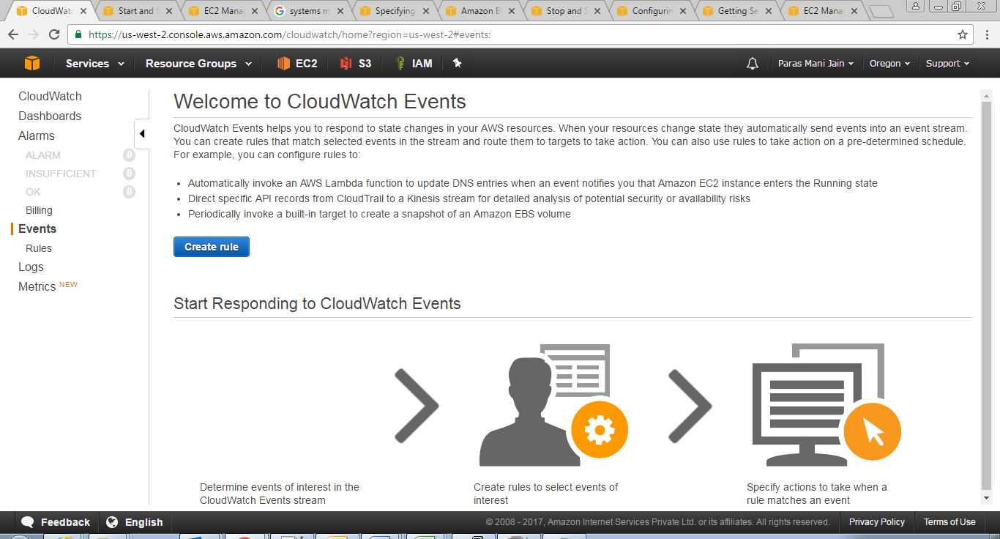

1. Select **Schedule** under **Event Selector,** select **Cron expression** radio button and give the desired cron expression depending at what time you want to stop/start the instance.
2. Click on **Add target** button under **Target** tab

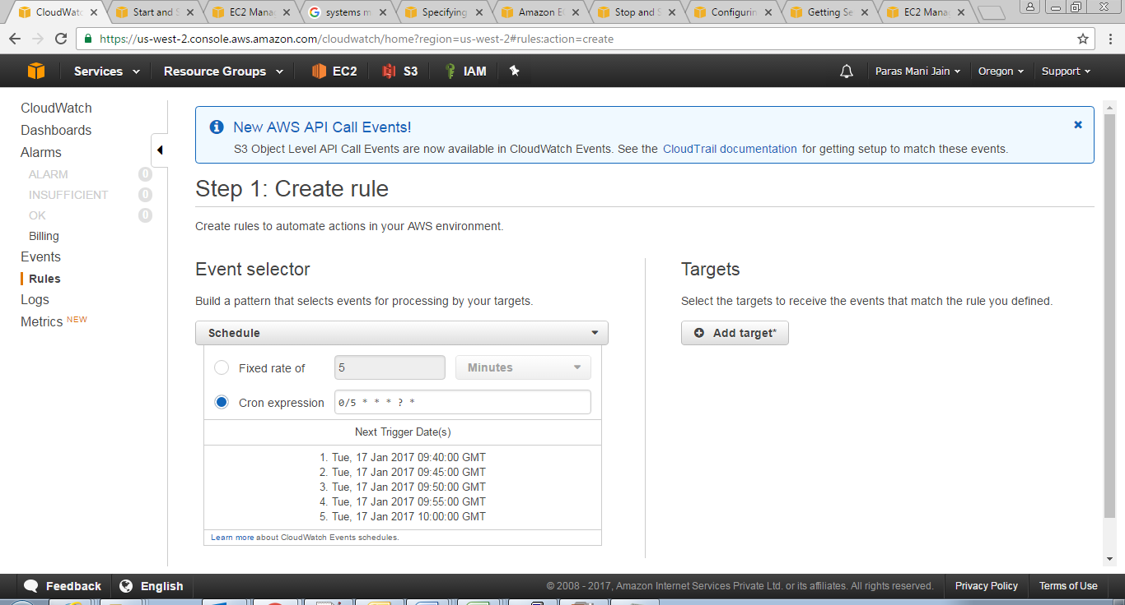

1. Choose your lambda function , click on **configure details** button

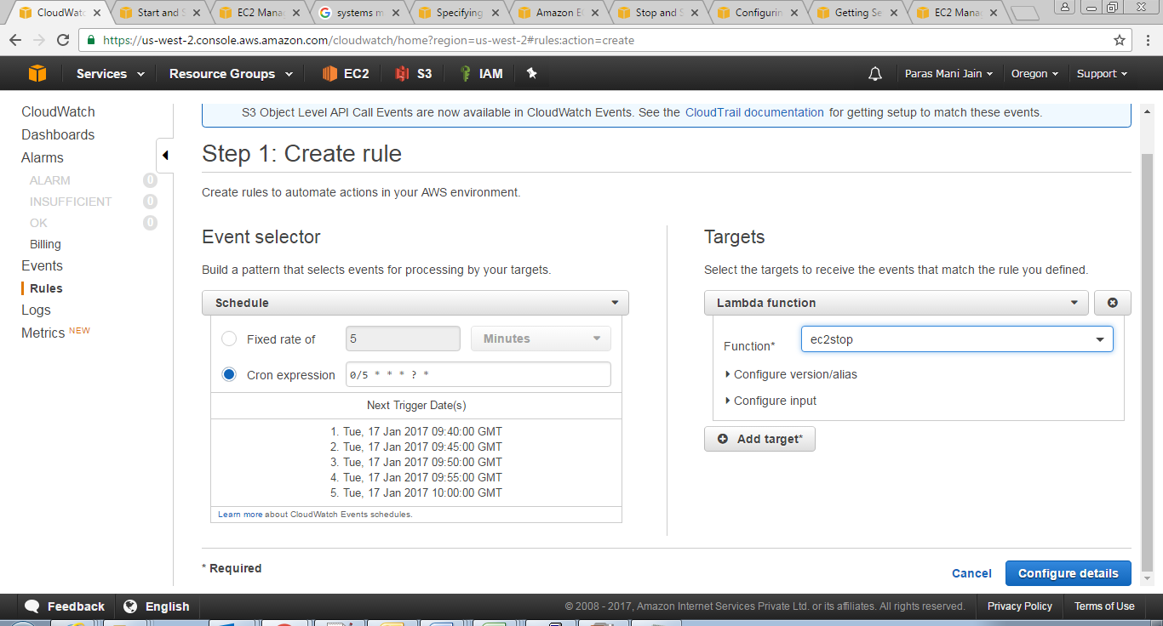

1. Provide the **Name, Description** set **State enabled** on**.**  Click on **Create Rule** button

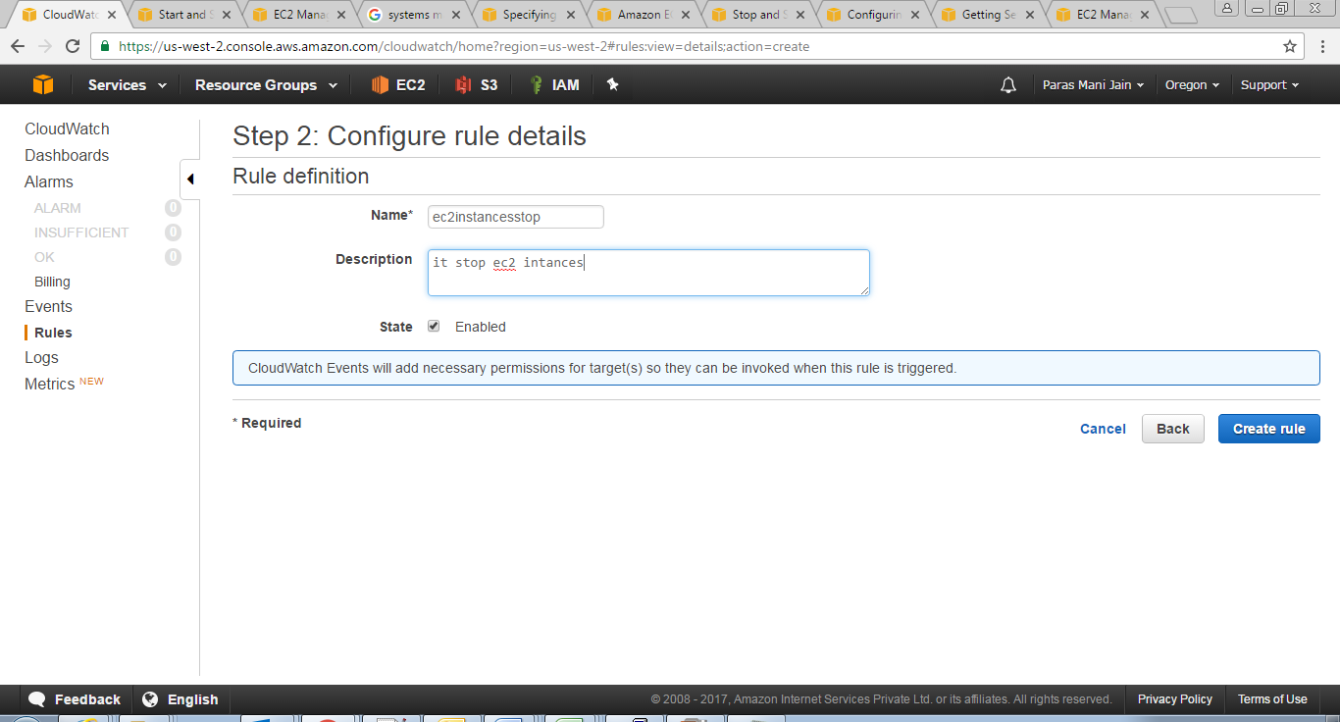

1. In **EC2 dashboard** you will observe that the instance is stopped

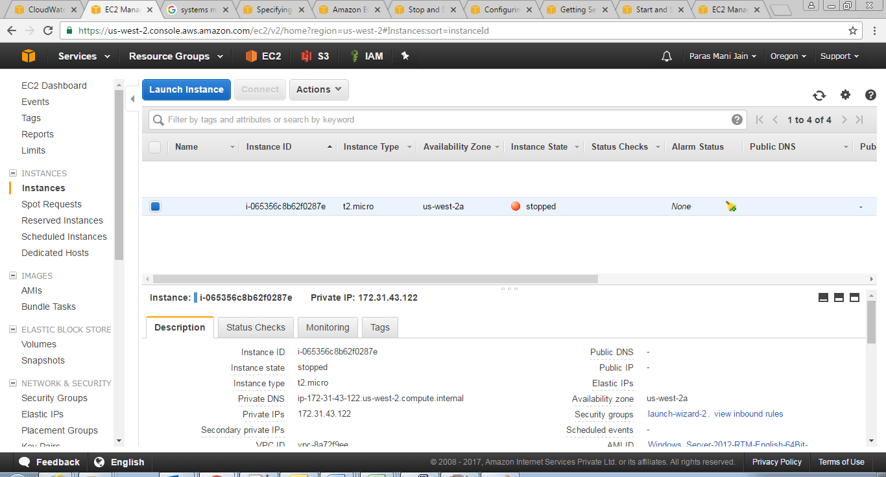

1. To view logs go to **CloudWatch Dashboard** and click on **Logs** from the left panel. Click on the logs under logstreams to view its detail

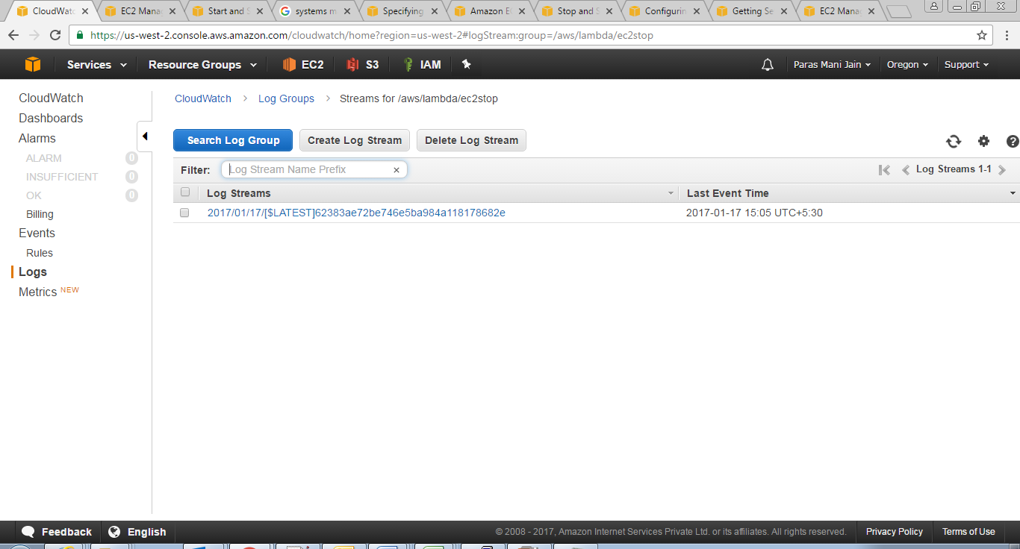

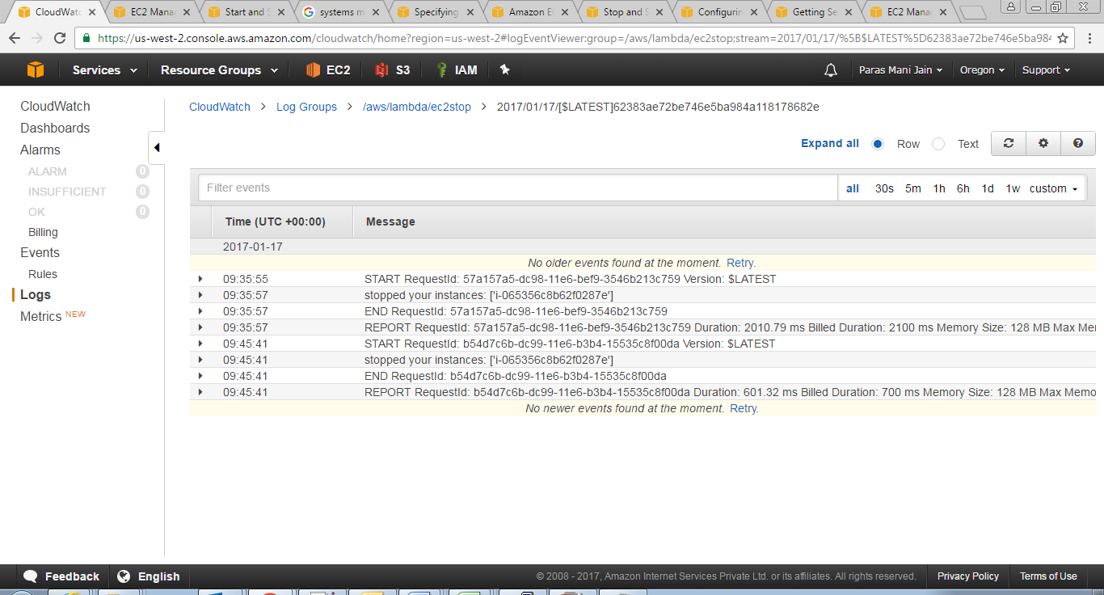

# References

http://docs.aws.amazon.com/